Th!nk Controller Removal and Identification
Please read this document completely before proceeding.
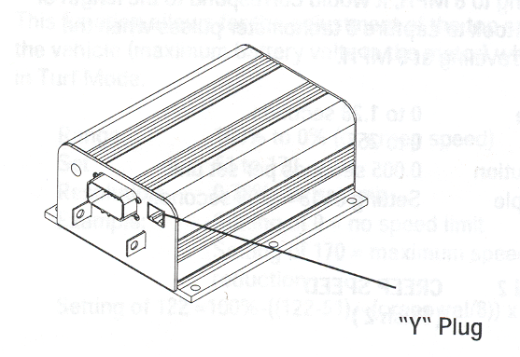

Identification
You will be requested to provide information as to if your controller is a revision 1 or 2. This can be easily determined by looking at the “Y” Plug or smaller data connector, above and to the right of the main 23 pin control/data connector. The “Y” Plug will have either 8 pins (REV1) or 12 pins (REV2).

Removal
If you look in front of the left rear wheel under and toward the center of the car, in front of the motor and gearbox assembly, you will see the controller. To remove it you MUST first shut off the service disconnect switch, this is under the driver's seat. Now the hard part, you must lift the rear of the car. This is so you can get to the controller; using a car hoist of course will provide you the easiest access. You can use ramps or a floor jack but this means you will be working on your back. If using a floor jack (do NOT use a bottle jack) place the jack in the center, just in front of the rear fenders with a 2x4 to spread the load across the chassis. Then support the vehicle with jack stands and remove the floor jack. Starting with negative (-) cable cut away the heat shrink insulation (Ford has determined that this insulation is not required and therefore no longer replaced)next remove all of the orange cables that connect to the controller one-by-one, it is suggested that after you remove each cable you tape the end just to be safe, these cables should already be marked but make sure, you should find 6 total, 2 on the left side of the car (+) & (-) and 4 on the right side (A1), (A2), (F1), & (F2). Next remove the large 23 pin control/data connecter, there is retention clip on the bottom side you must release; you can use a small screwdriver for this. Last remove the 4 hold down bolts.

It sounds like a lot but if you take your time it is quite simple and only takes about 30 minutes.

Installation Note: When re-installing the controller, connect the negative (-) cable last.

